Week-5
Q1: What are the key limitations of traditional MapReduce that make Spark a preferred choice for modern big data processing?
Ans. Key limitations of traditional MapReduce include:
- Disk-based processing: Intermediate results are frequently written to disk, causing high I/O overhead.
- Slow iterative processing: Machine learning and graph algorithms repeatedly process the same data, but MapReduce reloads data from disk in every iteration.
- High latency: Multi-stage workflows require multiple MapReduce jobs.
- Complex programming model: Developers must manually manage separate Map and Reduce stages.
- Poor performance for interactive queries: It is less suitable for real-time or interactive data analysis.
Spark is preferred because it supports in-memory processing, faster iterative computation, DataFrames, SQL, streaming, and machine learning libraries.

Q2: Explain how Spark uses In-Memory Computing to speed up iterative machine learning algorithms compared to disk-based systems.
Spark can cache intermediate datasets in RAM instead of repeatedly writing and reading them from disk.
For example, an iterative machine learning algorithm may use the same dataset many times:
Traditional MapReduce:
Disk → Read → Process → Disk
Disk → Read → Process → Disk
Disk → Read → Process → Disk

Spark:
Disk → Read → RAM
↓
Iteration 1
↓
Iteration 2
↓
Iteration 3
Original Dataset Created:

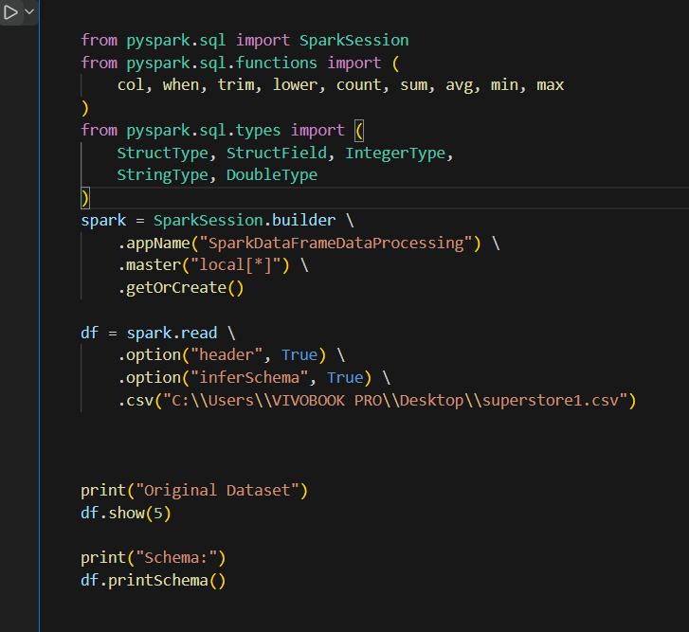

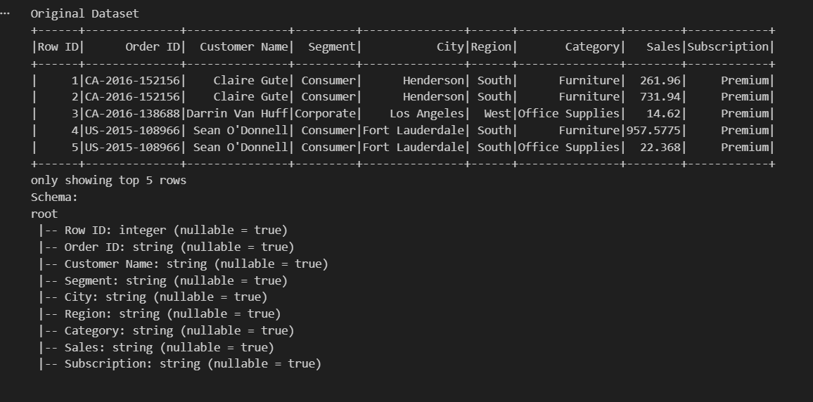

Q3: Write a code snippet to remove all duplicate rows from a DataFrame based on a specific set of columns: user_id and transaction_date.
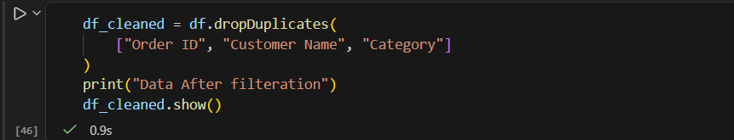

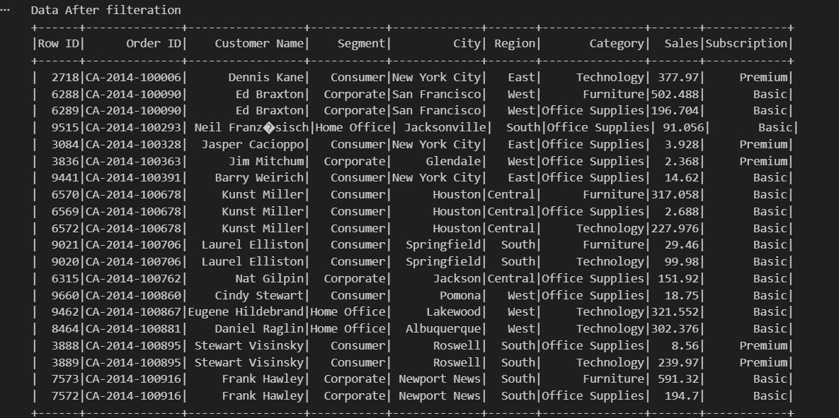

Q4: Given a DataFrame df_sales, write a query to filter for rows where the region is 'West' and then group by product_category to find the average sale_amount.
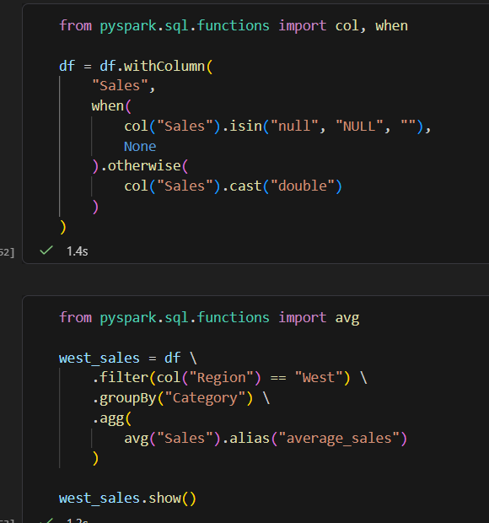

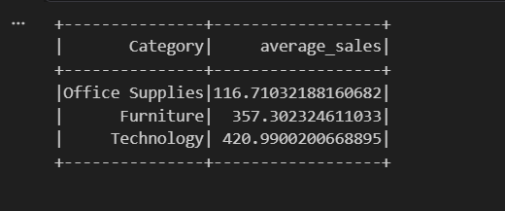

Q5: What is the difference between .na.drop() and .na.fill()? Provide a code example of filling null values in a status column with the string 'Unknown'.

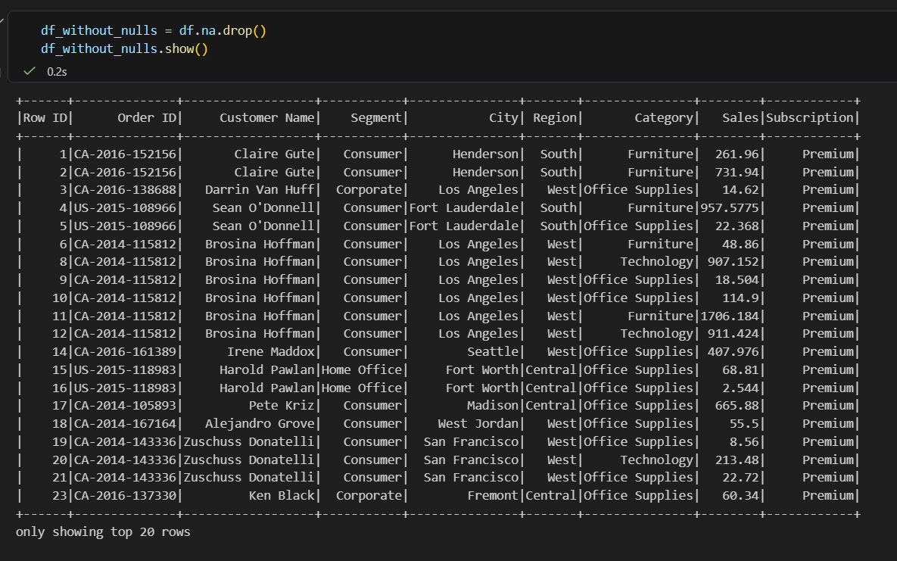

na.drop()
Purpose: Removes rows or columns with missing values.
Usage: df.na.drop() (in Spark) or df.dropna() (in Pandas).
Effect: Deletes the specified rows or columns that contain NA/null values, reducing the dataset size.
Parameters: Often includes parameters to specify the axis (rows or columns), how many NA values are required to drop a row/column (e.g., how='any' or how='all'), and a subset of columns to consider.
Example (Pandas): df.dropna(axis=0, how='any', subset=['column1', 'column2']
na.fill()
Purpose: Replaces missing values with specified or computed values.
Usage: df.na.fill() (in Spark) or df.fillna() (in Pandas).
Effect: Fills NA/null values with a specified value or strategy (e.g., mean, median), preserving the dataset size.
Parameters: Includes the value to fill with, or a dictionary mapping column names to fill values. In some libraries, you can also specify a method (e.g., method='ffill' or method='bfill').
Example (Pandas): df.fillna(value={'column1': 0, 'column2': 'unknown'}) or df.fillna(method='ffill')
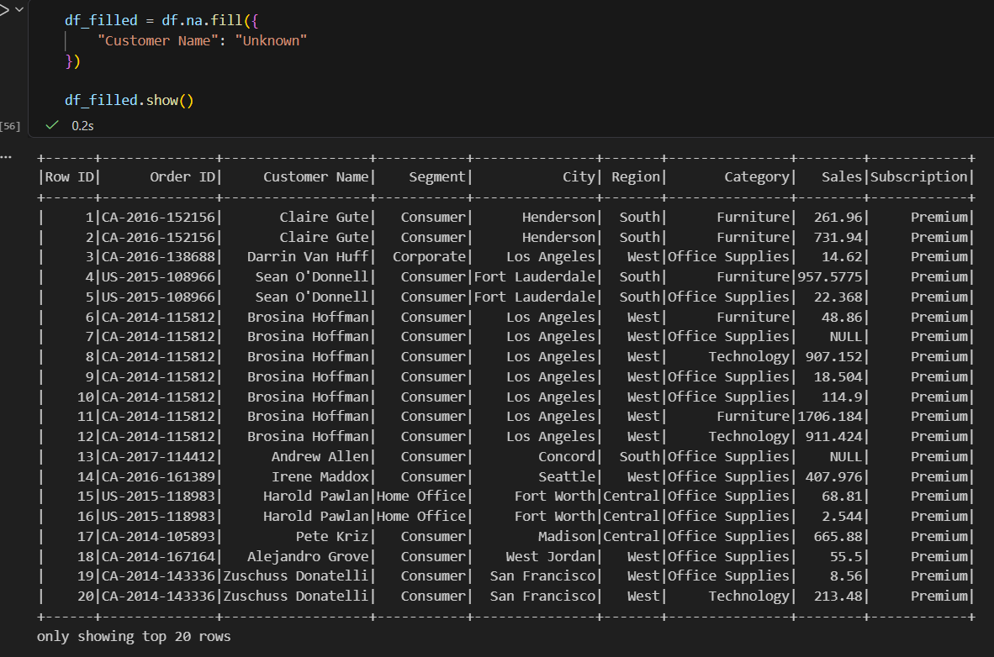

Q6: Write a query to find the total count of records for each city in a DataFrame, but only for cities where the count is greater than 100.
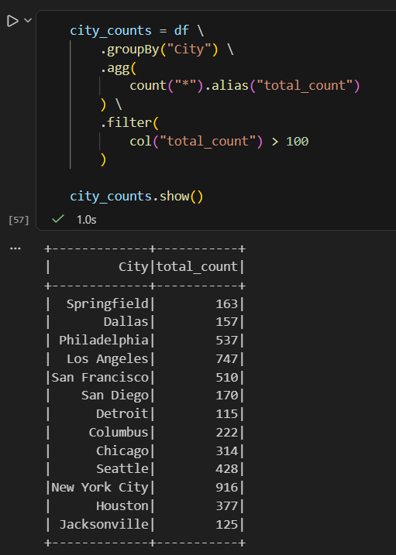

Q7: How does the immutability of Spark DataFrames affect how you perform "data cleaning" steps like dropping columns or renaming them?
Spark DataFrames are immutable, meaning the original DataFrame cannot be directly modified.
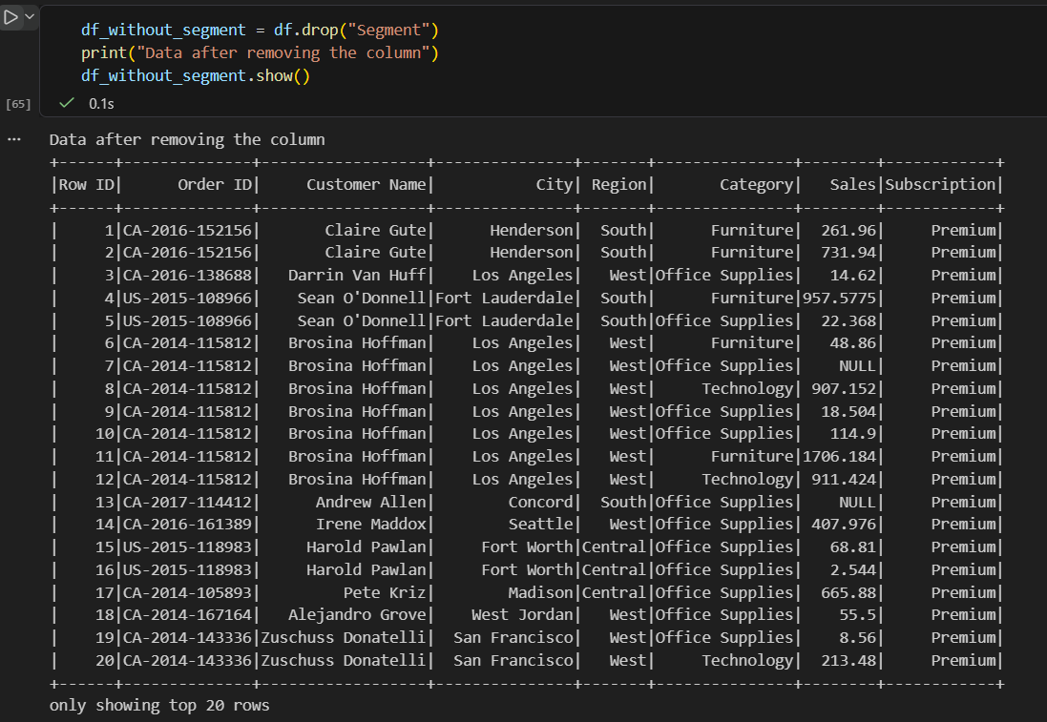

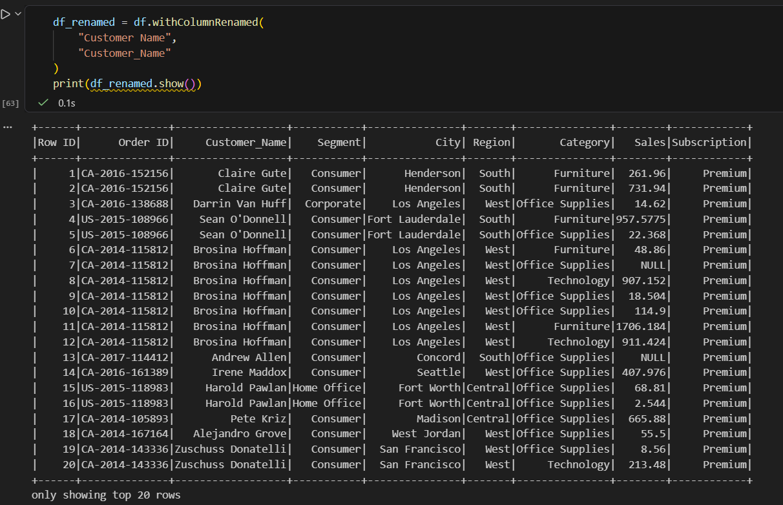

Q8: Write a Spark command to filter a dataset for rows where the age is between 18 and 30 (inclusive) and the subscription is 'Premium'.
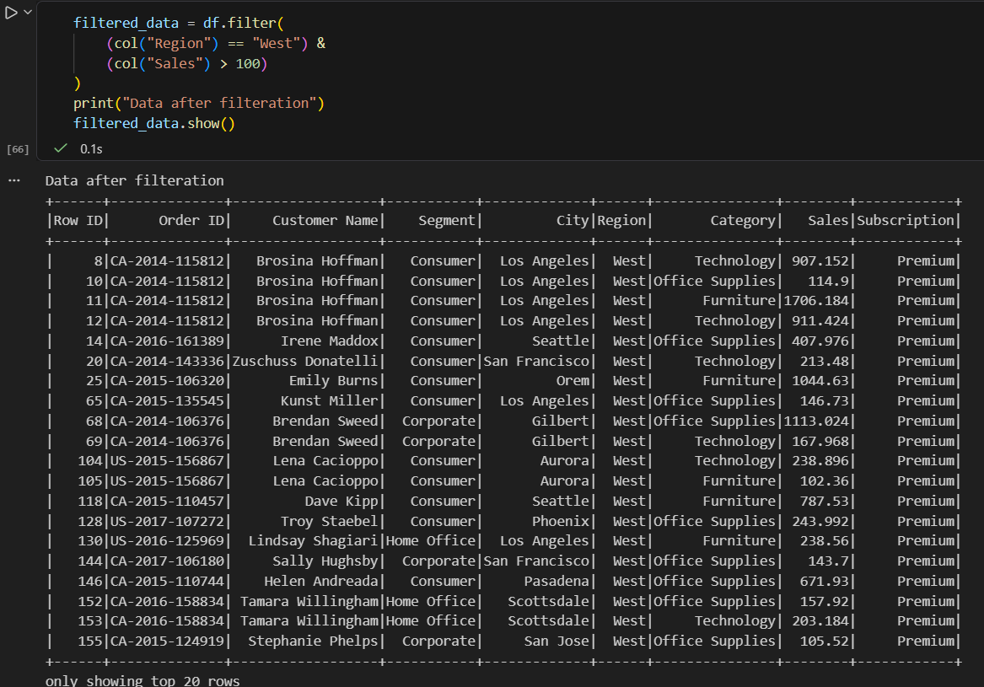

Q9: When cleaning a dataset, why is it often better to handle null values before performing mathematical aggregations like sum() or avg()?
Null values can affect the accuracy and interpretation of aggregations.
For example:
df.select(avg("price"))
Spark generally ignores null values in many aggregations, but missing data can still lead to:
- Incorrect averages
- Incomplete totals
- Inconsistent comparisons
- Misleading business insights
For example, replacing missing prices with zero:
should only be done when 0 is a meaningful representation of missing data. Otherwise, using an appropriate value such as the mean or median may be more suitable.

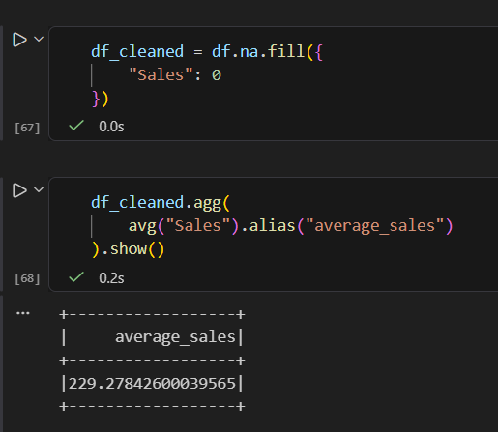

Q10: Write the code to revise a column named raw_timestamp by casting it to a TimestampType and renaming it to event_time.
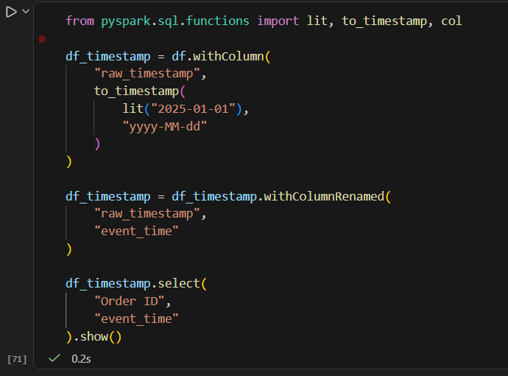

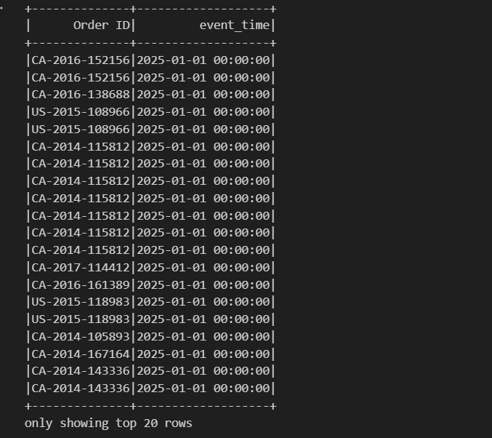

Q11: Explain the "Shuffle" process that occurs during a grouping operation. Why is it considered a wide transformation?

Shuffle Process in Spark
When Spark performs a grouping operation such as:
df.groupBy("region").agg(
sum("price").alias("total_sales")
)
the data is initially distributed across multiple partitions:
Partition 1: North, West
Partition 2: South, North
Partition 3: West, South
Spark must bring all records with the same grouping key into the same partition:
North → Same Partition
South → Same Partition
West → Same Partition
This movement of data between partitions is called a shuffle.
Why is groupBy() a Wide Transformation?
groupBy() is considered a wide transformation because an output partition may need data from multiple input partitions.
For example:
df.groupBy("city").count()
To calculate the count for one city, Spark may need to collect records from several different partitions.
Partition 1 ─┐
Partition 2 ─┼──► Shuffle ──► Grouped Partition
Partition 3 ─┘
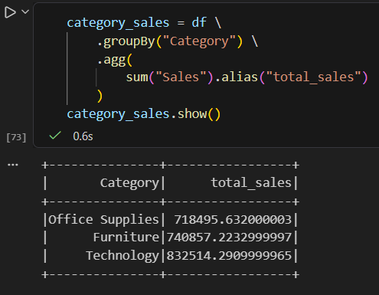

During this operation:
- Spark reads the records from the input partitions.
- It identifies the grouping key, such as Department.
- Records with the same department are moved to the same partition.
- Spark calculates the aggregation.
- The final grouped result is generated.
Why can Shuffle be expensive?
Shuffle can involve:
- Data movement between partitions
- Network communication
- Serialization and deserialization
- Memory usage
- Disk I/O if data does not fit in memory
Therefore, operations such as:
groupBy()
join()
distinct()
dropDuplicates()
can cause shuffling and are generally considered wide transformations.
In short: A shuffle is the redistribution of data across partitions so that records with the same key

Q12: Write a code snippet that identifies and removes rows where the email column contains null values OR the username is an empty string.
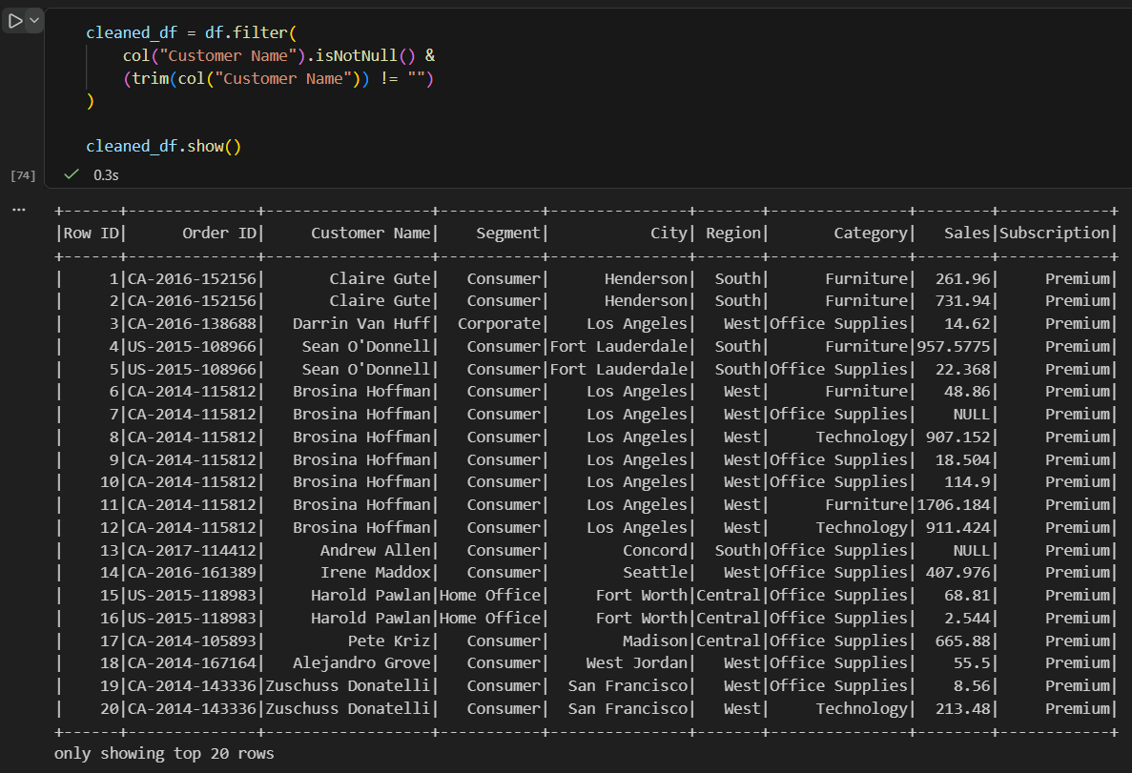

Q13: How do you use the .agg() function to calculate multiple statistics at once, such as the min, max, and mean of the price column?
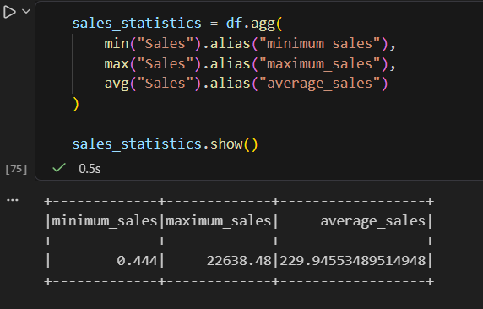

Q14: In the context of cleaning a dataset, what is the risk of using inferSchema=true when your source data contains messy or inconsistent date formats?
Q14: Risk of using inferSchema = true with inconsistent date formats
inferSchema = true tells Spark to automatically determine the data type of each column by examining the input data.
This can be risky when a date column contains inconsistent formats, such as:
2025-01-10
10/01/2025
01-10-2025
January 10, 2025
Spark may:
- Infer the column as StringType instead of a date/timestamp.
- Fail to parse some date values.
- Convert invalid dates to NULL.
- Interpret dates incorrectly due to different formats.
- Produce incorrect results when filtering or sorting by date.
For example, if dates are stored inconsistently:
2025-01-10
10/01/2025
2025/01/12
Spark may not reliably determine the correct date type.
Safer approach: Define the schema explicitly
from pyspark.sql.types import (
StructType,
StructField,
TimestampType
)

schema = StructType([
StructField(
"event_time",
TimestampType(),
True
)
])
explicit conversion :
from pyspark.sql.functions import to_timestamp, col

df = df.withColumn(
"event_time",
to_timestamp(
col("raw_timestamp"),
"yyyy-MM-dd"
))
Q15: Write a final processing pipeline that:
- Filters out duplicates.
- Fills null prices with 0.
- Groups by store_id to calculate total revenue.
